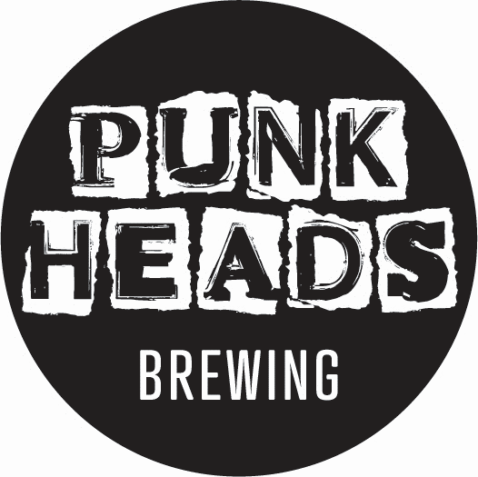

Pot Head WCIPA.

Brewery: Pacific Coast Beverages, Mangawhai, Northland

Hops: Strata, Mosaic, Nelson Sauvin and Talus.

Tasting Notes: Deep, tropical and punchy, with mango, pawpaw, coconut and pine flavours all balanced by a deep base of malts.
ABV: 6.8 %

IBU: 50

Packaging: 12 X 440ml cans
50 litre kegs

